# MySQL

Sakila Database

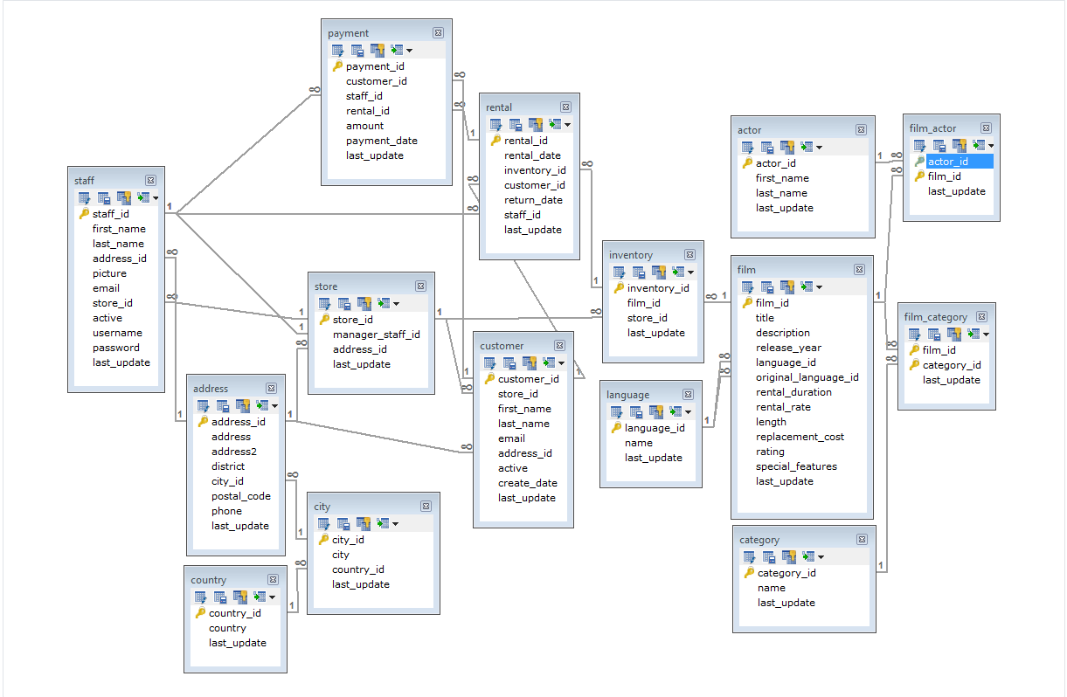

[Online Pics](https://raw.githubusercontent.com/Obrelix/.Net-MySql-Database-Connection-sakila-sample-database-/master/Schema/saqila.PNG)

HR Schema

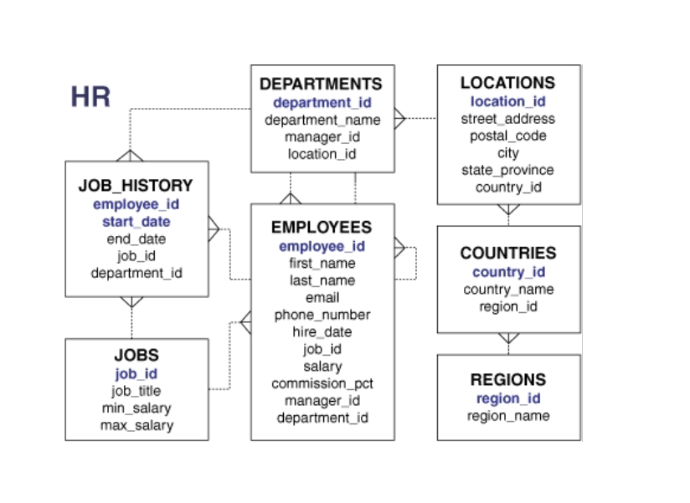

# **Where:**

The WHERE clause is used to filter records.

## Syntax:



# **Distinct:**

The SELECT DISTINCT statement is used to return only distinct (different) values.

## Syntax:



# **Like**

The LIKE operator is used in a WHERE clause to search for a specified pattern in a column.

There are two wildcards often used in conjunction with the LIKE operator:

* % - The percent sign represents zero, one, or multiple characters
* _ - The underscore represents a single character

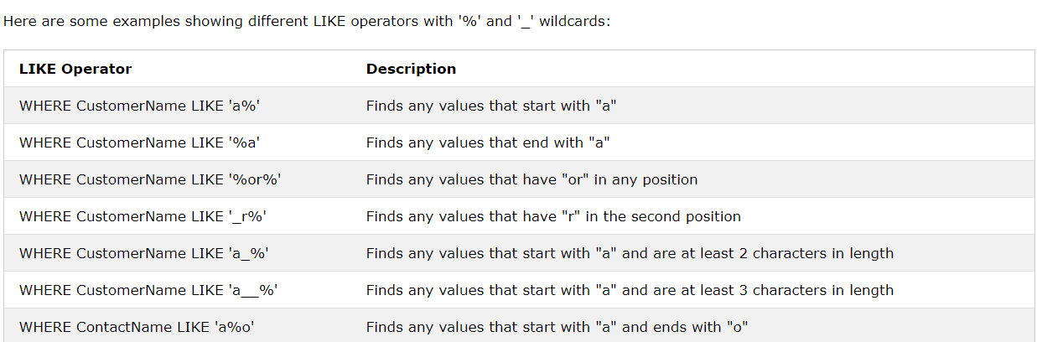

# **Conditions**

## **And**

The AND operator displays a record if all the conditions separated by AND are TRUE.

### Syntax



## **Or**

The OR operator displays a record if any of the conditions separated by OR is TRUE.

### Syntax



## **Not**

The NOT operator displays a record if any of the condition is FALSE

### Syntax



# **Order By**

The ORDER BY keyword is used to sort the result-set in ascending or descending order. The ORDER BY keyword sorts the records in ascending order by default. To sort the records in descending order, use the DESC keyword.

## Syntax:

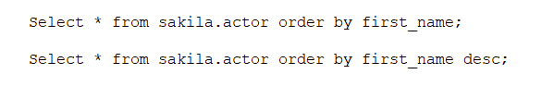

# **Aggregate Function**

## **Max**

The MAX() function returns the largest value of the selected column.

### Syntax:

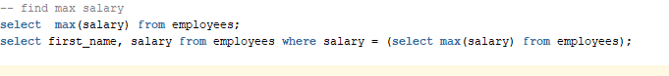

## **Min**

The MIN() function returns the smallest value of the selected column.

### Syntax:



## **Count**

The COUNT() function returns the number of rows that matches a specified criterion.

### Syntax:



## **Avg**

The AVG() function returns the average value of a numeric column.

### Syntax:

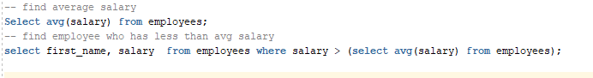

## **Sum**

The SUM() function returns the total sum of a numeric column.

### Syntax:



# **Other Functions**

## **In**

The IN operator allows you to specify multiple values in a WHERE clause.

The IN operator is a shorthand for multiple OR conditions.

### Syntax:



## **Between**

The BETWEEN operator selects values within a given range. The values can be numbers, text, or dates.

The BETWEEN operator is inclusive: begin and end values are included

### Syntax:



## **Top / Limit / Rownum**

The SELECT TOP clause is used to specify the number of records to return.

The SELECT TOP clause is useful on large tables with thousands of records. Returning a large number of records can impact performance.

**Note:** Not all database systems support the SELECT TOP clause. MySQL supports the LIMIT clause to select a limited number of records, while Oracle uses ROWNUM.

### Syntax:

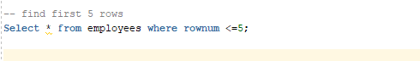

## **Rank**

## **Exist**

The EXISTS operator is used to test for the existence of any record in a subquery.

The EXISTS operator returns true if the subquery returns one or more records.

### Syntax:



## **Any**

The ANY and ALL operators are used with a WHERE or HAVING clause.

The ANY operator returns true if any of the subquery values meet the condition.

### Syntax:

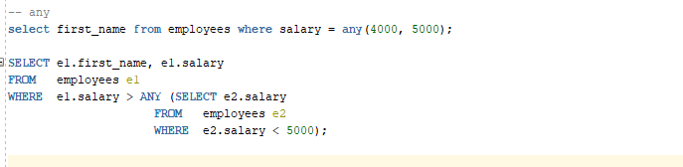

## **All**

The ALL operator returns true if all of the subquery values meet the condition.

# **Union**

# **Union All**

# **Group BY**

The GROUP BY statement groups rows that have the same values into summary rows, like "find the number of customers in each country". The GROUP BY statement is often used with aggregate functions (COUNT, MAX, MIN, SUM, AVG) to group the result-set by one or more columns.

## Syntax:

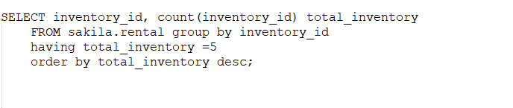

# **Having**

Having clause is used to filter the data when group by clause is used. Having is used after group by statement.

## Syntax:



# **Inner join:**

The INNER JOIN keyword selects records that have matching values in both tables.

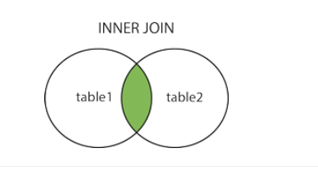

**This example is from MySQL Sakila Database**

## Syntax 1:

*regular*

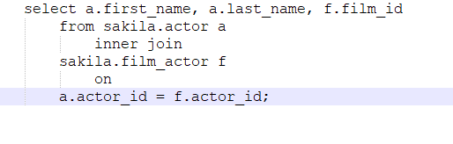

## Syntax 2:

*with “using”*

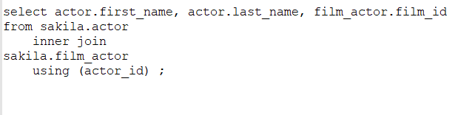

## Syntax 2:

*Without “inner” keyword*

